Do Economic Incentives Work? Evaluating the Effect of Incentives Designed to Attract Investment on State-Industry Growth Rates

A Research Proposal
submitted to the McCourt School of Public Policy
in partial fulfillment of the requirements for the
degree of
Master of Public Policy
By
Christian Conroy
[Abstract: Economic development scholars remain divided over whether economic incentives designed to attract businesses to a particular locality ultimately promote job growth, wage increases, and economic development or whether they just give away vital taxpayer dollars. While some research has found that economic incentives may nudge a company to choose one location over a similar location, others have argued that companies make location decisions based on strategic considerations like human capital and supply chain networks, and not based on economic incentives. At the same time, even if companies are choosing to locate to a particular locality based on an economic incentive package, it is not clear that the growth they bring is enough to compensate for the loss of tax revenue. In this paper we evaluate the impact of five different types of state-level economic incentives on growth in GDP and employment levels. We use a novel Panel Database on Incentives and Taxes established by the W.E. Upjohn Institute for Employment Research that contains data on marginal business taxes and business incentives for 45 industries in 47 cities in 33 states collected from 1990 to 2015. Using several estimation strategies, including two-way fixed effects longitudinal modeling, difference-in-differences (DD), and difference-indifference-in-differences (DDD), we expect to find that the economic incentives have little to no impact on the level of economic and growth for an industry in a particular state over time.]

Introduction

The almost reality-television style competition 19 U.S. cities and Toronto found themselves in over 2018 as a result of Amazon’s public bid for the company’s next headquarters renewed a conversation in America over whether the economic incentives that these cities offered the market platform behemoth actually result in development and employment. Economic development scholars have suggested that there is a causal relationship between the use of economic incentives designed to attract businesses and resulting growth in state-level GDP growth over time in the United States. The most common argument is that a company that chooses to locate in a state offering an incentive package will ultimately bring jobs, wage increases, and state and local economic growth that will more than compensate for the short-term loss in tax revenues (Peters and Fisher 2004, Bartik 2003, Bartik 1991). Others have further argued that it is often the case that the incentives are what pushes a company to choose one location over another similar location that is offering less in cost reductions (Bartik 2005, Rubin 1991, Chapman and Walker 1990, Walker and Greeenstreet 1989, Schmenner 1982).
If the theory of chain is as these scholars argue, namely that tax-reducing incentive packages nudge large companies to choose specific locations and those companies subsequently create jobs and economic output that benefits the local economy, then it makes logical sense that local economic development authorities would continue to leverage this tool. However, there are only a few studies within the empirical literature that suggest that economic incentives like property tax abatements, R&D tax credits, job creation tax credits, and other tools lead to economic growth at the local and state levels (O’Connor 2011, Busso and Kline 2008, Bartik 2005, Wu 2005, Peters and Fisher 2004, Wasylenko and McGuire 1985, Newman 1983). For example, Peters and Fisher (2004) find that offering a job creation tax credit equal to $2,800 per job for a branch plant would result in an increase of 30% in the probability of a firm choosing the offering location over a similar location not offering the incentive. Busso and Kline (2008) evaluate the federal urban Empowerment Zone program and found evidence that local economic development incentives led to significant conditions in employment and economic growth. The findings of these studies, however, have not gone unchallenged.
A greater portion of the literature argues that economic incentives are not effective in attracting companies that in turn will provide jobs and economic growth. Several studies argue that economic incentives are not a significant factor in the decision making calculus of a firm and such tools therefore provide taxpayer money to a firm that had already chosen to locate to the area due to factors related to ease of living, human capital support, or corporate strategy (Peters and Fisher 2004, Weber 2000, Rondinelli and Burpitt 2000, O’Mara 1999, Lynch 1995). Rondinelli and Burpitt (2000) found through surveys that executives of multinational firms place factors like quality of life and transportation infrastructure high while ranking state taxes and finance consistently low. Even accepting that an economic incentive package might lure a company to a particular location, some studies have argued that once there the economic benefits will not outweigh the costs (Blomström 2002, Rodríguez‐Pose and Arbix 2001). According to another prominent argument, economic incentives might attract large companies and translate to increased short-term growth, but they also will crowd out investment or create sub-optimal capital allocation in the long-term (Wilson 2009, Gorin 2008, Peters and Fisher 2004, Fisher and Peters 1997). Wilson (2009) looks specifically at R&D tax incentives, arguing that while they do increase R&D spending within the state in the short-term, they also draw it away from other localities in the long-term, resulting in no net gain overall. With challenges presented at each point along the causal chain, it seems difficult to prove the effect of incentives on increasing economic growth over time.
The empirical evidence showing no relationship or even a negative relationship between economic incentives and state-level GDP growth naturally accentuates that challenge. Numerous studies have shown that economic incentives packages do not return the economic development benefits over time that they purport to (De Blasio, Fantino, and Pellegrini 2014, Peters 2002, Rodriguez-Pose and Arbiz 2001, Boarnet and Bogart 1996, Schweke, Rist, and Dabson 1994, Carlton 1983). For example, De Blasio, Fantino, and Pellegrini (2014) exploited a shortage of funding for an innovation subsidy program to apply a regression discontinuity design (RDD) and find that the program was not effective in producing the economic spillovers through increased innovation that it was intended to. The central finding of all the studies cited above was that there was a breakdown somewhere in the mechanism that translates tax reduction incentives into company attraction into increased economic development.
Rather that attributing the breakdown in the causal relationship between economic incentives and state-level GDP growth to the concept of the incentive itself, other scholars have pointed out design features that may make incentives more or less likely to promote economic growth in the long-term. Some have pointed to skill gaps in local economic development authorities that doom complex incentives structures from the start (Dewar 1998). Others sympathize with heads of economic development authorities as they are bound by the competing incentives of higher-level government authorities with electoral interests (Jensen and Malesky 2018, Dewar 1998). Bartik (2017) argues that shorter-term incentives that front-load tax breaks and subsidies have a higher likelihood of influencing relocation decisions and affecting long-term economic development prospects due to the way corporate accounting processes function. The most developed strand of the literature emphasizes the importance of including clawback provisions and performance requirements within economic incentives deals in order to hold recipient companies accountable to the jobs and economic growth they promised to bring when initially seeking the tax reductions (Bartik 2005, Ledebur and Woodward 1990, Bartik 2003). Given the complexities of locational tax effects, this strand of the literature appears to offer the most applied evidence for policymakers tasked with considering both whether incentives are useful and how they should be designed.
Clearly, the empirical literature that seeks to identify the effects of economic incentive programs on economic growth is mixed. While there are many potential reasons for the inconclusiveness, in part, methodological shortcomings in several of the studies highlights above may be to blame. Specifically, several studies, such as Fleischmann, Green, and Kwong (1992), Rondinelli and Burpitt (2000), Schmenner (1982), Walker and Greenstreet (1989), and Rubin (1991) rely on data collected through surveys. While much can be learned, results that are produced are not useful in interpreting the effect of incentives as answers are subjective, question items can be interpreted differently, and respondents might even be incentivized to exaggerate the positive effects of an incentive package if they think they might be soliciting such bids again at some point in the future. Others used case-studies that held little external validity (Bartik 1987). Several studies taking econometric approaches mismatched geographic targets, analyzing the effect of city-level incentives on state economic growth or state-provided incentive programs on the economic prospects of a city within that state (Coughlin and Cartwright 1987). Several looked at specific incentive programs without creating a sufficient control group upon which to compare how a company made its allocation decision or whether a company’s entrance resulting in increased economic development in the absence of incentive programs.
Studies of enterprise zones and other relatively "large" economic development programs suffer from a second problem: it is difficult to determine what would have happened to the local area without the program (Busso and Kline 2008). Lastly, some studies like Wu (2005) and Wilson (2009) focus only on the immediate effects of an incentive (i.e. whether R&D tax credits increase R&D spending) as opposed to the long-term effects on economic growth.
Given the competing narratives and empirical shortfalls, thesis will ask the research question:

Do incentives offered by state and local governments to attract businesses actually result in increased business activity and positive GDP growth?

In attempting to answer the research question posed, this study will be carrying out one of the most comprehensive causal studies of the effect of economic incentives on state-level economic growth to date. This paper employs a longitudinal analysis model controlling for fixed effects and a difference-in-difference (DiD) estimator using state-industry level data that will control for endogeneity and identify the relationship between incentive packages offered at the state and local level and GDP growth at the state level. Unlike previous studies that have focused on one specific incentive program or one type of tax incentive, this study will evaluate five different types of business incentives, including: job creation tax credits, property tax abatements, research and development tax credits, and customized job training packages.
This study overcomes the challenge in creating a counterfactual against which to identify a causal relationship by leveraging a database developed through a “tax and incentive simulation” (Bartik 2017). First applied to economic incentives by Peters and Fisher (2002), under this modeling structure, a business in some industry i creates a new branch facility to be set up in city c in state s that will start operation in year t. The “output, value-added, real and personal property, labor, and purchases of intermediate inputs” the branch facility would bring comes from a constructed balance sheet derived from Federal government sources (Bartik 2017). State and local taxes, the nominal value of incentives, and the changes in inputs and outputs over time for a firm are then calculated for each year using real information for each city, state, industry, and incentive format. Overall, what amounts to 65 percent of total state and local business taxes is covered in the dataset, with that number being higher for industries that are not subject to taxes left out of the database such as public utility taxes and insurance premium taxes.
Several studies have applied unique approaches to studying the causal effect of fiscal incentives, though few have effectively applied such approaches to analyzing the impact of multiple types of incentives on state-level GDP growth. Cleeve (2008) applies a multiple regression analysis that controls for autocorrelation and heteroscedasticity of standard errors through rho transformation and the application of robust standard errors, respectively, to conclude that fiscal incentives like tax holidays are important in attracting foreign direct investment. Wilson (2009) applied a DiD estimator allowing for state and year fixed effects with state-level panel data from 1981-2004 to find that R&D tax incentives may have short term benefits but only at the cost of crowding out R&D spending in surrounding states in the long-term. Lastly, De Blasio, Fantino, and Pellegrini (2014) exploit a temporary lapse in funding for an innovation subsidy program to argue that incentive recipients do not ultimately end up producing more patents compared to firms not receiving the subsidy. While each of these studies took an innovative approach to analyzing a specific incentive, the research questions they posed were not intended to align with the question of whether economic incentives actually lead to economic development at the state level.
The rest of the paper is organized as follows. The second section provides background on economic incentive programs and how they are structured at the state and local levels. The third section covers the sampling methodology, data sources, and design used in our analysis. The fourth and fifth sections detail the statistical approach and empirical results. The final section concludes.
Background: Different Types of Economic Incentives [Broaden out perhaps to focus more on what has been used, the statutory nature, etc.]

To assess the relationship between economic incentives and economic growth, we focus on five different types of economic incentives: investment tax credits, job creation tax credits, R&D tax credits, property tax abatement, and custom job training subsidies. While this list is not exhaustive – the database does not include geographically targeted incentives like opportunity zones or tax increment financing (TIF) incentives – it does cover the majority of incentive dollars spent by at the state and local level to attract medium to large size firms. Each of the five types of incentives included in this study operate differently in general and across states and industries and it is therefore important to provide an overview of how the incentives work.
Investment tax credits consist of relief applied against a company’s tax liability based on specific criteria regarding the type of incentive. Criteria is typically set based on the amount of investment, the target of the investment, the size of the investing firm, and the industry that the firm carrying out the investment operates within. For example, the InvestArk investment tax credit program in Arkansas provides tax credits against sales and use tax to firms in specific industries that invest at least $5 million in a plant or “equipment for new construction, expansion, or modernization” (Summary of Tax Incentive Programs 2016). Investment tax credits in Connecticut and Oklahoma offer tiered investment tax credits based on both the level of investment and the number of employees at the investing firm (Summary of Tax Incentive Programs 2016). The tax liability will differ and industry and state and local governments therefore often tailor investment tax credits are therefore often tailored based on specific criteria as opposed to be applied uniformly across industries.
Job creation tax credits are similar to investment tax credits and only differ, as the name suggests, by what the company must do in order to receive the tax credit. Firms receiving job creation tax credits against tax liabilities usually have to demonstrate a number of jobs that will be created, types of jobs that will be created (full-time, part-time, temporary, etc.), and an average payroll for those jobs, with the level of credit received often tiered based on different levels of annual payroll. For example, Delaware provides a job creation tax credit of $500 for each job while Mississippi provides the credit as a percentage of new payroll (Francis 2016). The level of investment and scale of job creation are typically parts of every economic incentive deal package and there are few occasions when the job creation tax credit will be offered without the accompaniment of the investment tax credit and visa versa.
While the job creation and tax credits apply to tax liabilities a company will incur simply for operating in a specific location, the R&D tax credit applies to expenses a company chooses to spend on research. While the administration of R&D tax credits looks slightly different across states and industries, all programs typically measure the level of credit against tax liabilities based on change from a base year R&D spending and a set forward carry based on the timeline of research. For example, Indiana provides companies a tax credit against liabilities on 15% of the first $1 million in R&D spending above the prior three-year base that can be carried forward for ten years (Miller and Wathen 2014). R&D tax credits often differ across states and industries by what spending qualifies as R&D, what industries or research purposes qualify for the credit, what percentage of spending qualifies for the credit, and what the carry forward time is for the given credit.
The central difference between the tax credits laid out above and the property tax abatement is that credits are applied to reduce tax liabilities whereas abatements simply reduce the liability level from the start. In the case of property taxes, abatement consists of delaying taxes on existing property and improvements or expansions until a specified period. For example, Indiana provides 100% tax abatement for three years for companies that occupy 50,000 sf of vacant building space, invest at least $10 million in property, locate in a high unemployment tract, or rehabilitate a dilapidated building in a designated area (Miller and Wathen 2014). Different states maintain different R&D tax credit policies, but all typically involve some level of property tax abatement for property expansions, renovations, or improvements related to manufacturing, supply chain, R&D, and information technology (Miller and Wathen 2014).
Unlike tax credits and abatements, the custom job training subsidy simply provides a lump-sum grant distribution to firms based on demonstrated training needs, typically on a per employee basis. For example, New Mexico’s Job Training Incentive Program provides funding for up to six months for green and manufacturing companies that export a significant portion of products out of state (New Mexico Economic Development). Grants can be distributed up front based on a firm’s demonstrated need or through reimbursement after qualified training is conducted.
Data Sources and Collection [Go back through the panel and make sure we got this figured out]

Data Sources

The W.E. Upjohn Institute for Employment Research Panel Database on Incentives and Taxes is the only open-access database that aggregates all the information used in calculating incentives, taxes, and economic returns by city, state, and industry into one database, and contains data on marginal business taxes and business incentives for 45 industries in 47 cities in 33 states collected from 1990 to 2015. The database covers five types of business incentives, including: job creation tax credits, property tax abatements, research and development tax credits, and customized job training packages. While not all cities and states that have used incentives to attract businesses are covered in the dataset, the coverage is more than representative: the 33 states compose 92 percent of US GDP and the 45 industries compose 91 percent of US labor compensation. Such coverage will allow us to effectively assess both the overall effects incentive packages on GDP growth and the effects broken down by industry, geographical grouping, and type of incentive offered.
It is important to note that the dataset is not a repository of actual incentives that state and local governments have offered to businesses like that maintained by Incentives Monitor. Instead, the database is derived from carrying out a “tax and incentive simulation” whereby a business in some industry i creates a new branch facility to be set up in city c in state s that will start operation in year t. The “output, value-added, real and personal property, labor, and purchases of intermediate inputs” the branch facility would bring comes from a constructed balance sheet derived from BEA Industry accounts data, IRS data on Statistics and Income, and National Science Foundation data on R&D spending (Bartik 2017). State and local taxes, the nominal value of incentives, and the changes in inputs and outputs over time for a firm are then calculated for each year using real information for each city, state, industry, and incentive format. Information on state and local taxes includes: business property taxes from the Lincoln Institute of Land Policy and the Minnesota Center for Fiscal Excellence, state taxes on corporate income and state gross receipts taxes from the Commerce Clearing House’s State Tax Guides, Overall, what amounts to 65 percent of total state and local business taxes is covered in the dataset, with that number being higher for industries that are not subject to taxes left out of the database such as public utility taxes and insurance premium taxes. Information on incentive rates comes primarily from the Council for Community and Economic Research (C2ER), Good Jobs First, documents describing local laws and policies, and the websites of city and state economic development authorities. Please see the full description of the methodology used to create the dataset for further reference.
In addition to the merged datasets that comprise the database, the panel is merged with a dataset drawn from the Bureau of Economic Analysis (BEA) system containing annual GDP by state in aggregate and for each industry. The GDP data collected by BEA is comprised of three components: labor income (wages, salaries, and other benefits), business taxes (excise, sales, property, and other business expense taxes), and capital income (income earned by individual or business and deprivation). Each data point is collected through a rigorous methodology that includes estimation using BEA’s state personal income (SPI)and industry accounts, business payment and financial data from the Census Bureau, and value-added data from the Department of Agriculture.
In addition to state-industry level controls drawn from the Panel Database on Incentives and Taxes, we collected state-level control characteristics from the Bureau of Economic Analysis and state government finance variables from the Census Bureau. State-level control variables are used as part of the propensity score matching process described below and included as control variables in all three of the model specifications described below. Due to the fact that Washington DC is dropped from the sample when incorporating state government finance variables, all model specifications are run both with government finance variables and without.
The challenge with merging the Panel Database on Incentives and Taxes (explanatory variables) with the BEA GDP by state for each industry is that there is a discontinuity in the data at 1997 due to the decision by BEA to convert from industries defined by SIC codes to those defined by NAICS codes. Federal statistical agencies use NAICS to collect and analyze data related to the U.S. economy, with each digit of the code system, representing a progressively narrower detail: the first two digits represent the economic sector, the third the subsector, the fourth the industry group, the fifth the NAICS industry, and the sixth the national industry. While tools to crosswalk SIC and NAICS codes do exist, it is impossible to match the definitions without over or under counting the GDP levels of specific industry groupings and BEA even cautions scholars against trying to append the datasets together to develop a consistent timeline for 1963 to 2016. The state economic profile variables that serve as state-level control covariates also only capture 1998 onwards. In light of this challenge, the decision was made to reduce the dataset down to the years 1998 through 2015. The resulting full dataset contains 19,568 observations.
While the primary research question of this paper focuses on the effect of each of the five economic incentive types on the GDP growth of an industry in given state over time, we will also seek to evaluate the aggregate effect of the economic incentives. Not only will this allow us to determine whether the tool of economic incentives promotes economic growth for industries, but in comparing the aggregate effect with the individual effects, we can better determine whether or not one incentive or a few incentives comprise the majority of the effect (if there is an effect) of the aggregate economic incentive impact on GDP growth for an industry in a given state. Furthermore, industries are often not receiving one incentive type but are instead often receiving the combined tax abatement of all types of economic incentives, so including an aggregate measure of incentive abatement allows us to control for the confounding effects of all economic incentives.
To create a measure of aggregated incentive tax abatement, we build an index constructed from the tax abatement levels for all five incentive types that each state-industry receives on annual basis. Using the methodology described by the University of Warwick Centre for the Study of Globalisation and Regionalisation (CSGR) for replicating the UNDP Human Development Index (HDI), we construct the index by 1) normalizing the five annual tax abatement levels for each state-industry, 2) averaging the normalized tax abatement levels into one variable, and 3) weight the normalized index by multiplying the average normalized tax abatement level by each state-industry’s annual percent GDP contribution for the state (Guide to Using the Index).
Table 1 provides descriptive statistics for the dependent, explanatory, and control variables. As mentioned above, the primary specification we are interested in includes state-industry level GDP as the dependent variable and the level of tax abatement for each of the economic incentive types per state-industry as the explanatory variables. In the table below, we also include summary statistics for variables included in the model specifications with state-level GDP as the dependent variable and for those in which the five economic incentives tax abatement variables are combined into a weighted index.
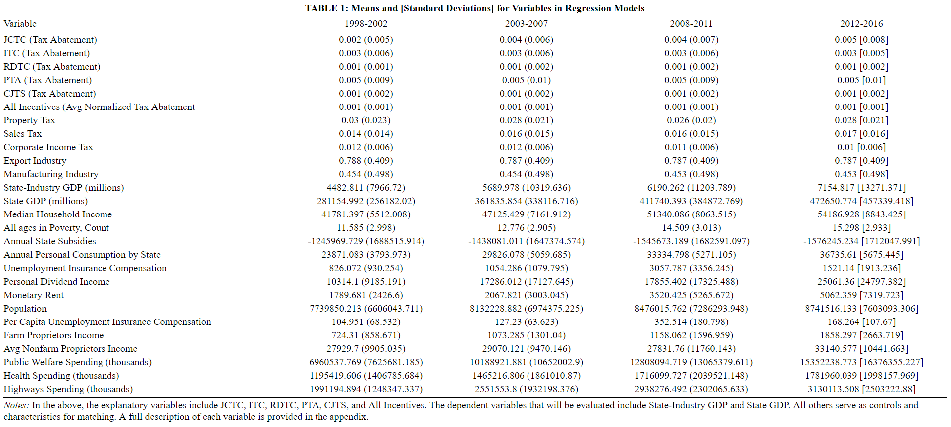

Figure 1 below shows the distribution of state-industries that received each incentive in any given year. As the figure shows, a significant growth in the number of state-industries receiving Research and Development tax credits occurred between 1997 and 2015, ultimately surpassing the number of state-industries that were receiving custom job training subsidy packages in 2008 during the heart of the financial crisis. At the same time, more and more state-industries began receiving job creation tax credits over the data collection period, with a significant jump occurring around 2006. Property tax abatements tend to be utilized the least, which makes sense given that property taxes often serve as the primary source of revenue generation for municipalities across the country. It is important to note that the incentives are not mutually exclusive and one state-industry may have received several or all of the incentives on any given year.

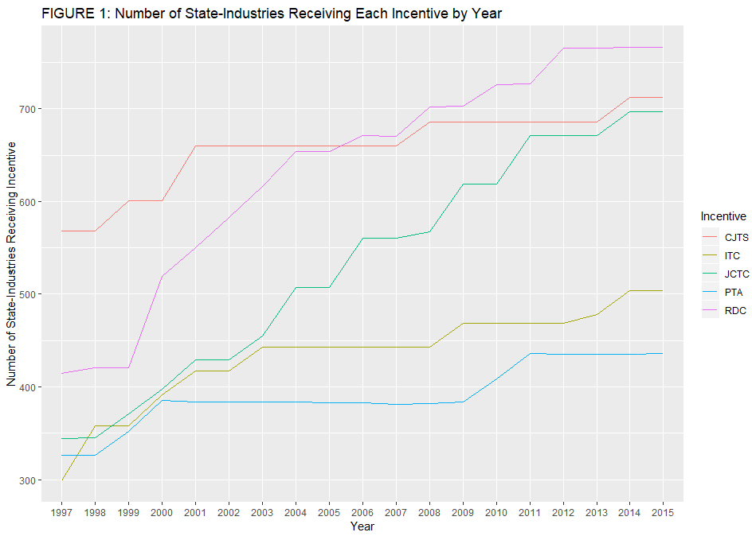

Figure 2 below shows the distribution of average economic incentive tax abatement received for all state-industries over the data set period. As the figure shows, state governments significantly increased the amount of job creation tax credit tax abatement as a tool to attract businesses, which makes sense given the need for politicians to create jobs to get reelected. At the same time, in absolute terms, property tax abatement tends to provide the highest level of relief for companies, though the level of abatement provided for the job creation tax credit reaches roughly the same average level by 2015. The level of tax abatement over time is consistently lowest for the research and development credit and custom job training subsidy, which may potentially be related to the hypothesis that companies relocating will pay more attention to incentives like property tax abatement than they will to research and development credits or custom job training subsidies. It is important to note that the incentives are not mutually exclusive and one state-industry may have received several or all of the incentives on any given year. It is important to note that there appears to be an almost inverse relationship between Figure 1 and Figure 2 with states providing more expensive economic incentives to less industries and visa versa.

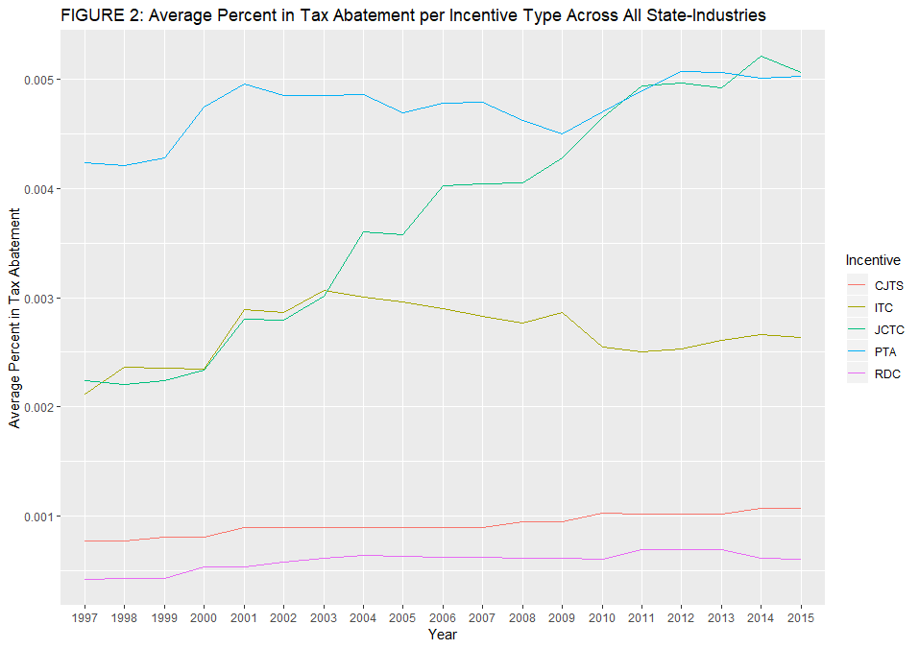

Analytical Approach

There are three parallel longitudinal approaches that will be taken to test the hypotheses that five different types of economic incentives – job creation tax credits, research and development tax credits, investment tax credits, custom job training subsidies, and property tax abatement – each have a positive effect on economic growth at the state-industry level.

Two-Way Fixed Effects [Add Clustered Standard Errors]

In the first approach, we will model an OLS regression specification with the tax abatement at the state-industry level for each economic incentive type being included as independent variables and GDP at the state-industry level as the dependent variable. While we are interested in assessing the effect of the tax abatement for each incentive type, because GDP growth will vary based on all the incentives being offered by a state to an industry in any given year, each incentive must be included to control for the effect of the incentive in question on GDP growth. Specifically, we estimate the following OLS specification:

𝑌= +𝛽₁JCTC₁₊+𝛽₂RDC₂+𝛽₃ITC₃+𝛽₄CJTS₄+𝛽₅PTA₅+ 𝜀_{𝑖t}
where Y_{sit} is the GDP for an industry i in state s in year t; is a constant; 𝑋_{𝑘} represents the five primary independent variables, and is equal to some number less than one equivalent to the rate of tax abatement for each economic incentive (k=1,2,3,4,5); 𝜀_{𝑖𝑠} serves as the error term.
In order to control for systematic differences across states and the years for which data is collected that are potentially correlated with the rate of tax abatement from each particular incentive, we use an adjusted multivariate regression including two-way fixed effects. First, state-level fixed effects will be included to capture differences across the 33 states included in the sample. Second, year-level fixed effects will be included to account for potential shocks in a given year (the years covering the financial crisis are included in the dataset, for example). The adjusted model can be written as:

is a term that represents any characteristics of state-industries that differ over time not controlled for by state-industry fixed effects. The terms represent the effect of the tax abatement of each incentive on the GDP of a specific state-industry at time t. All incentives are included in the model as the level of abatement for each incentive will affect the effect of the level of tax abatement for each economic incentive we are interested in on state-level GDP at time t. The sit subscript signifies that the average value of the dependent variable will differ for each state-industry and year. serves as the error term.
Because of the panel nature of our data, there is a risk that

Two-Way Fixed Effects Stratified by Propensity Score Matching
Due to the inability to conduct a randomized control trial in which each type of financial incentive would be randomly allocated to industries at a fixed rate, there is a risk that the characteristics of industries receiving a certain combination or higher degree of economic incentives (the “treatment” group) end up being poorly balanced with those industries receiving no incentives or a lower degree of economic incentives (the “treatment” group). While we minimize this risk by including state and industry level control variables, as well as unit and time level fixed effects, we still are at risk of the problem of “common support” whereby subgroups created by the control variables are dominated entirely by observations in the treatment group with no observations from the control group or visa versa.
We will use propensity score matching to find common support and reduce the bias of sample selection across observable the variables in the Panel Database. A propensity score consists of the probability that an observation would be assigned to a treatment group or control group if random sampling had been used. This approach involves coding state-industry-year observations as binary based on whether an industry in a state during a given year received a particular incentive (rate of abatement is non-zero) or did not receive an incentive (rate of abatement is zero).
Because we are interested in evaluating both whether individual economic incentives impact state-industry GDP growth and whether the combination of economic incentives lead to state-industry GDP growth, we employ six separate matching processes whereby the state-level control variables are regressed on binary variables signifying whether or not a state-industry received any incentive or each of the four incentives specifically in any year, respectively. Propensity scores are assigned to group members by using a probability model with the treatment variable as the dependent variable and control variables as covariates to create predicted probabilities for having received treatment. Propensity score matching works under the assumption that if some range of propensity scores spans the same region for the treatment and control groups then the covariates underlying those scores are likely to show common support between the two groups within that range. Weights are retained from matching and used in determining which observations to drop or count more than once.
We will calculate the Average Treatment Effect Among the Treated (ATT). The alternative would be to calculate the Average Treatment Effect (ATE), which would be more suited to multiple treatment studies that seek to evaluate the compound effect of receiving one treatment up to receiving all treatments. Calculating the ATT involves comparing the mean GDP of a state-industry that received an incentive with the mean GDP of those same state-industries had they not received the incentive.
After matching and obtaining the weights, the weighted (frequency weights) two-way fixed effects is run to obtain the the average treatment effect on the treated (ATT) for each of the stratum used in the study. The doubly-robust estimate of the average treatment effect is represented by the associated regression coefficient.

Long-Run Effects
It is likely that the effects of small tax abatements brought through economic incentive packages will not be felt immediately in the industries in the states providing the incentives. Instead, it is more likely that the effects will be felt more in the long term as more companies in that industry come to the state to take advantage of the incentives and as other firms relocate to take advantage of agglomeration effects and industry clustering. Because we have we have 18 years of economic incentives and state-industry GDP growth, we are well positioned to estimate the long-run effects of economic incentives on state-industry GDP growth.
Using the approach perfected by Neumark and Shirley (2017), we combine the approaches of our first two specification approaches above by interacting for each year period the dummy variables used in our propensity score matching analysis with the single-period values used in the two-way fixed effects regression specification. We then compute the average of the resulting products across the time period of our dataset. Because the dummies were generated based on whether a tax abatement for a specific incentive was zero or non-zero, this translates into computing the average tax abatement for each economic incentive type, as well as for the weighted average index of the incentives, across the 18 years of the dataset. Because we still need to ensure that we do not confound the effects of the economic incentives in the long-term, we also still include in the model specification a term representing state and industry control characteristics in 1998 at the start of the dataset time period. Specifically, we evaluate the following model:
[Look back at Eissa’s writing in my notebook]
Where x is x and blabla.
This model should account for.
Robustness Checks
Calcagno and Thompson (2004) find that the existence of general-equilibrium-specific-factor models of production results in a negative correlation between economic incentives and industry value-added because firms provided economic incentives pull resources from those not provided incentives. The logic, as explained by Thompson (1985) is that economic incentives result in labor gravitating towards the industry receiving the subsidized capital, resulting in a lower ratio of capital to labor and a decreased output for the rest of the economy. We therefore add another layer of analysis by using state-level GDP, as opposed to state-industry GDP, for a given year as the dependent variable in the specifications described above. The goal in including this dependent variable is to evaluate whether any improvement in one state-industry might be coming at the cost of inducing negative effects on the broader state economy. For example, while tax incentives provided to the metal manufacturing industry may increase GDP growth form that industry in the long-term, there is a possibility that it might crowd out economic growth in other industries, resulting in net neutral or negative impact on state level-GDP growth.
Underlying the hypothesis we test through empirical analysis in this study is the assumption that a company will choose to relocate to a state based on the economic incentives being offered. However, there are a number of reasons that a company may choose to locate to a specific place other than economic incentives, including amenities, access to human capital, and economic agglomeration effects. To account for these factors, we also include as a robustness check variables related government spending on healthcare, welfare, and highways. While other government finance variables such as spending on education and intergovernmental transfers are also important to motivating firm relocation decisions, preliminary analysis showed significant multicollinearity when education and intergovernmental transfers variables are included, leading to the conclusion that including only variables related to healthcare, welfare, and highways spending is sufficient.
We include government finance controls as a robustness check as opposed to including in our main model specifications due to the fact that the inclusion of state government finance variables drops any observations for the District of Columbia from our analysis. As part of the robustness check, the government finance variables are used during the propensity score matching process to evaluate whether an industry is more likely to receive incentives based on whether a state might already effectively attract firms without economic incentives due to great public amenities. At the same time, the government finance variables serve as alternative control variables in our primary three model speciation types.
Empirical Results
Applied Longitudinal Two-Way Fixed Effects Model
Table 2 below shows the results for the two-way fixed effects regression and long-run effects models with both the aggregate incentives variable and each individual incentive serving as the independent variables and state-industry GDP serving as the dependent variable.

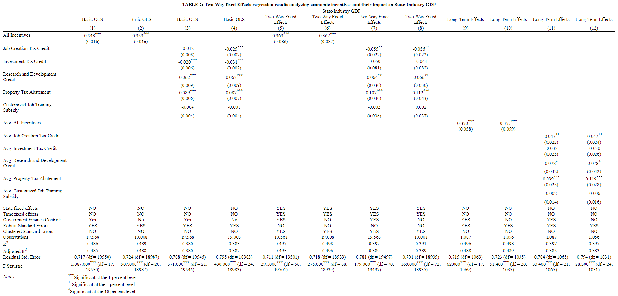

All variables have been standardized in order to facilitate easier regression coefficient interpretation given that the coefficients would be significantly large when the independent variables are measured in terms of percent tax abatement and the dependent variable is measured in terms of millions of dollars. The first thing that is striking across our results is that while economic incentives in the aggregate showed a positive statistically significant effect, the effect for each incentive individually is much more complex, with some showing a positive effect, some a negative effect, and others no statistically significant impact.
According to our two-way fixed effects regression model, the results show that a one standard deviation increase in the economic incentive tax abatement offered to a state-industry is associated with a .363 standard deviation increase (significant at the 1 percent level) in the GDP generated by that industry (Table 2, Column 5). Given the positive effect of offering economic incentives, it therefore makes sense that, as our descriptive statistics showed, that the number of state-industries receiving all incentive types would rise consistently across our panel time period.
In breaking down which economic incentives most contributed to the positive effect of economic incentives in the aggregate, it appears that property tax abatement played the most significant role. When we control for state-level and industry level characteristics and include state and time level fixed effects, the coefficient on property tax abatement is positive and statistically significant at the 1 percent level (Table 2, Column 7). This suggests that standard deviation increase in property tax abatement is associated with a 0.107 standard deviation increase in the GDP generated by that industry. Though not as statistically significant (significant only at the 5 percent level), there is a positive coefficient for the research and development credit (0.064) as well.
It is also important to note that the magnitude of the positive effect of economic incentive sin the aggregate is being pulled down by the negative effect of the job creation tax credit, which is statistically significant at the 5 percent level. Though the negative effect of the tax abatement for the job creation tax credit (-0.055) is not as strong in absolute terms as either the research and development credit or the property tax abatement (0.064 and 0.107, respectively), it is enough to allow us to conclude that it is not enough to simply estimate the effect of economic incentives in the aggregate.
Results show that though the correlation coefficients for investment tax credit and custom job training subsidy (Table 2, Column 7) indicate negative directionality, the absolute values of the coefficients are quite low. Not only do the absolute values of the coefficients the investment tax credit and custom job training subsidy remain consistently low – .-050 and -.002 respectively – but neither variable is statistically significant at the 10 percent level or below. There is therefore no evidence to suggest that the offering of either economic incentive is correlated with higher GDP growth in the targeted industry.
The results remain relatively unchanged when government finance variables are added to the model. In fact, for those variables that were statistically significant in the two-way fixed effects model not controlling for government spending – economic incentives in the aggregate, the job creation tax credit, the research and development tax credit, and property tax abatement – adding government finance variables to the model consistently increases the magnitude of the respective effects (Table 3, Columns 6 & 8).
When the four functions of education management (teacher discipline, education equipment purchasing, school facility maintenance, and supplementary instructional material purchasing) are included together (Figure 5), the results indicate that students at primary schools where teacher discipline is managed through a centralized approach scored .176 SD higher (5 percent level) than their counterparts at schools in which teacher discipline was primarily administered at the school level. Similarly, results from the full model indicate that students at schools where principals identified education equipment purchasing as being managed through a decentralized approach scored .203 higher (10 percent level) than students at schools that reportedly practiced centralized management of the same function. By contrast, the degree of centralization over school facility maintenance and supplementary instructional material purchasing has no statistically significant correlation with student achievement. The results from the full model are consistent with quantitative findings from the independent multivariate regressions of each function of education management on student performance.

Long-Run Fixed Effects
The second thing that is striking across our results is that the effects are surprisingly consistent across model specifications as we add state and time level fixed effects, add government financing variables, and adapt the analysis to estimate long-run effects

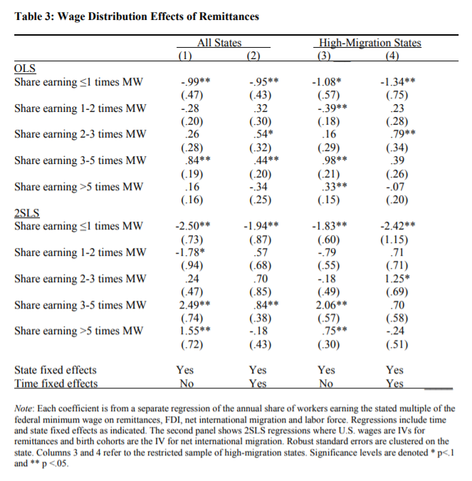
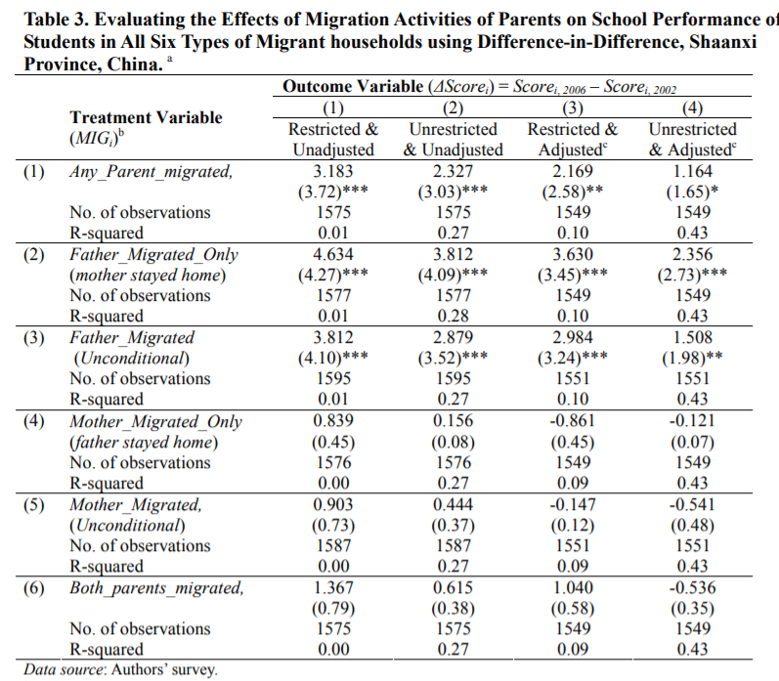
^ Above can be model for PSM Model with economic incentive types and aggregate on the left and bands on the right (Will prob want a full page then with landscape mode)

Will want to couple the above with the below. Look at REAP Study again for further guidance ->
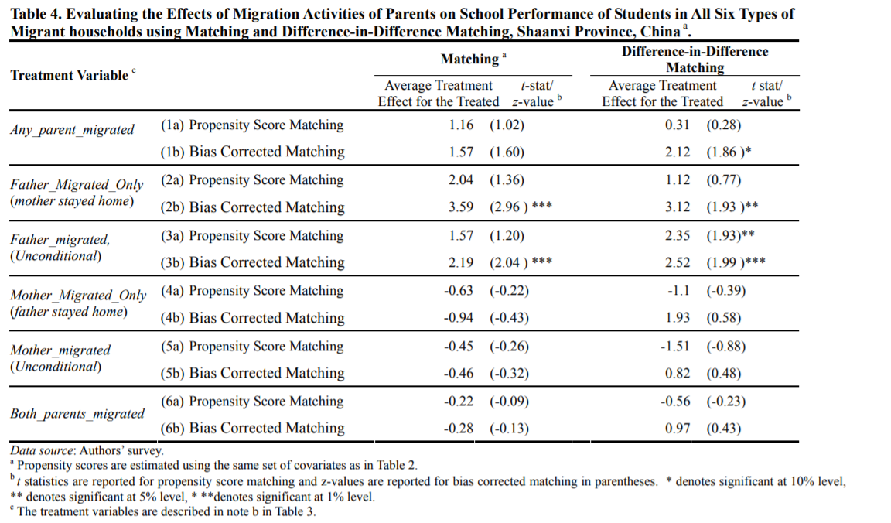

^ 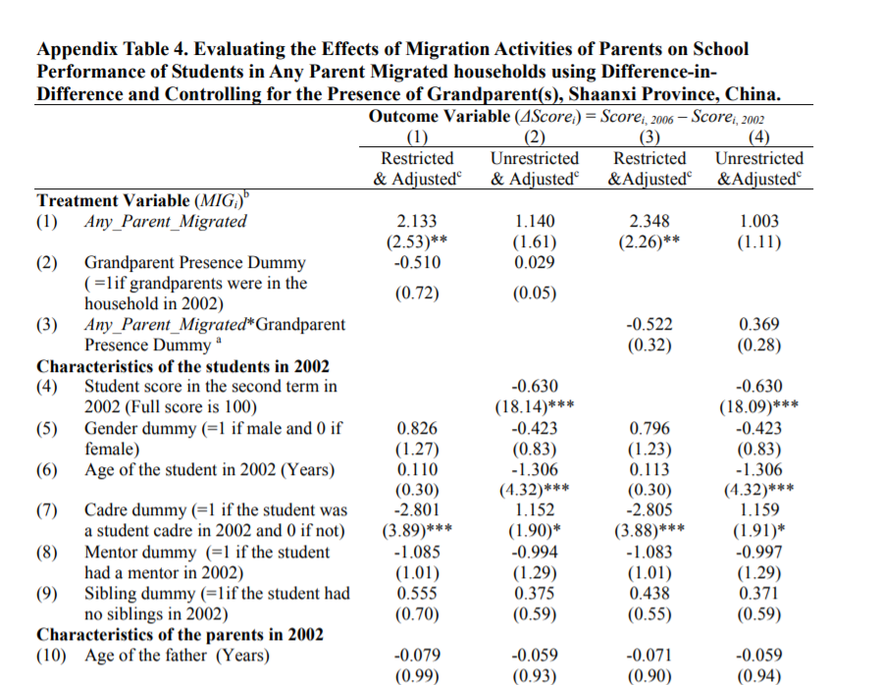

^ Something like the above to include control variables in the PSM process

Exposure Variable/Dynamic Model
All models with linear tax rates had larger R2 and greater tax impacts than models in which taxes entered in log form and coefficients on tax rates were never statistically significant in log-log models [Mention here as well that you’ve tried to change the specifications to log-log, log-lin, and lin-log forms and quadratic/polynomial formulations, especially with the index var. Kind of a Laffer curve phenomena]
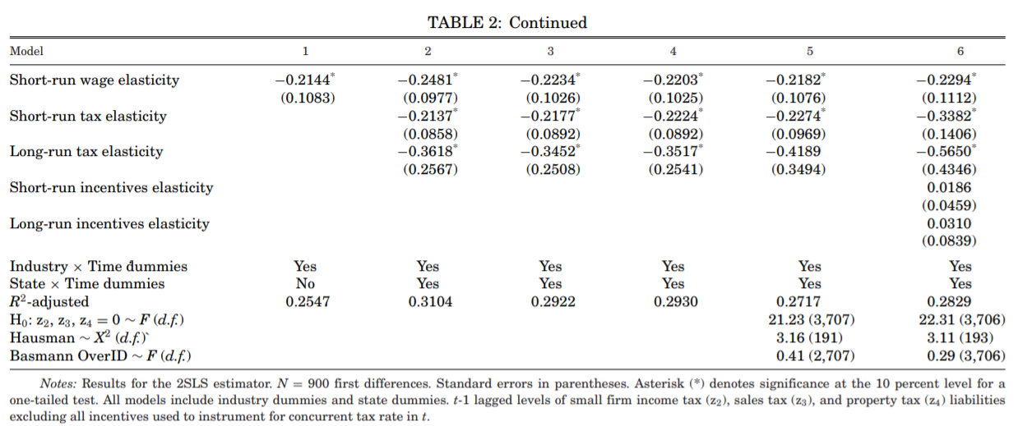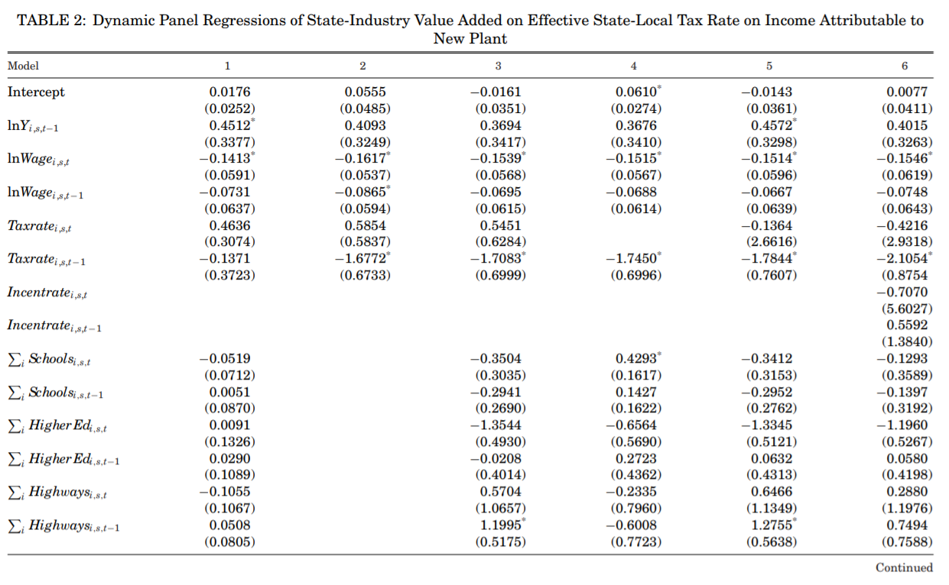
Next Steps
While the first level of analysis – basic panel data model controlling for two-way fixed effects – has been concluded, there are still several econometric variations that need to be run and evaluated.
First, there are two distinct measures that can be used to control for unit-level characteristics that differ across time. First, information drawn from the U.S. census, BEA, and Bureau of Labor Statistics (BLS) collected at the state and industry level can be included in the model. While this will likely not control for all characteristics that differ across industries and states and time – environmental disasters that might affect a given state and industry on a given year will be hard to control for example – it will create more accurate results. Second, the unit-level fixed effects can be interacted with the time-level fixed effects to create a DDD that aims to control for all unknown characteristics that differ across states and industries and time. While this measure is less precise than the first measure, it is an alternative to controlling for characteristics that differ by unit and time when actual information cannot be collected.
In addition to the panel data model controlling for two-way fixed effects, the full analysis will also include a DiD model that focuses on the adoption of economic incentives as opposed to the changing rate of abatement from the economic incentives. While treatment and control groups have been created based on whether an industry in a state during a given year received a particular incentive or did not receive an incentive, the separate models have not yet been run and evaluated.
Finally, for both the panel data model controlling for two-way fixed effects and the DiD model, alternative dependent variables need to be included to assess the impacts of economic incentives on different macroeconomic factors. State-level GDP, as opposed to state-industry level GDP will be included as the dependent variable in both models to assess whether any improvement in one state-industry might be coming at the cost of inducing negative effects on the broader state economy. Job growth at both the state-level and at the state-industry level will respectively be included in the models to evaluate the claims made by economic development authorities and politicians regarding the positive effect of economic incentive on job growth. Not only will the inclusion of these dependent variables provide another layer of analysis to back up any positive or negative narrative regarding economic incentives, but it will also add another layer of robustness to the empirical process.
Conclusion
Limitations: Second, because economic development officials often advertise job growth as the main benefit of offering economic incentive packages, we will also conduct further specifications using annual job numbers by industry in each state. Job growth and economic growth do not necessarily occur in parallel, so this will provide another layer of analysis that will allow us to assess whether an industry might be adding many jobs but with little translation into economic output.

Works Cited
Bartik, Timothy J., et al. "Saturn and state economic development." (1987).
Bartik, Timothy J. "Who benefits from state and local economic development policies?." (1991).
Bartik, Timothy. "Local economic development policies." (2003).
Bartik, Timothy J. "Solving the problems of economic development incentives." Growth and Change 36.2 (2005): 139-166.
Bartik, Timothy J. "A new panel database on business incentives for economic development offered by state and local governments in the United States." (2017).
Bia, Michela, and Alessandra Mattei. "A Stata package for the estimation of the dose–response function through adjustment for the generalized propensity score." The Stata Journal 8.3 (2008): 354-373.
Blomström, Magnus. "The economics of international investment incentives." (2002).
Boarnet, Marlon G., and William T. Bogart. "Enterprise zones and employment: evidence from New Jersey." Journal of Urban Economics 40.2 (1996): 198-215.
Burgette, Lane, Beth Ann Griffin, and Dan McCaffrey. "Propensity scores for multiple treatments: A tutorial for the mnps function in the twang package." R package. Rand Corporation (2017).
Busso, Matias, and Patrick Kline. "Do local economic development programs work? Evidence from the federal empowerment zone program." (2008).
Calcagno, Peter T., and Henry Thompson. "State economic incentives: Stimulus or reallocation?." Public Finance Review 32.6 (2004): 651-665.
Carlton, Dennis W. "The location and employment choices of new firms: An econometric model with discrete and continuous endogenous variables." The Review of Economics and Statistics (1983): 440-449.
Chapman, Keith, and David F. Walker. Industrial location: principles and policies. Blackwell, 1991.
Cleeve, Emmanuel. "How effective are fiscal incentives to attract FDI to Sub-Saharan Africa?." The Journal of Developing Areas (2008): 135-153.
Coughlin, Cletus C., and Phillip A. Cartwright. "An examination of state foreign export promotion and manufacturing exports." Journal of Regional Science 27.3 (1987): 439-449.
De Blasio, Guido, Davide Fantino, and Guido Pellegrini. "Evaluating the impact of innovation incentives: evidence from an unexpected shortage of funds." Industrial and Corporate Change 24.6 (2014): 1285-1314.
Dewar, Margaret E. "Why state and local economic development programs cause so little economic development." Economic Development Quarterly 12.1 (1998): 68-87.
Fadlon, Itzik, and Torben Heien Nielsen. Family Labor Supply Responses to Severe Health Shocks. No. w21352. National Bureau of Economic Research, 2015.
Fisher, Peter S., and Alan H. Peters. "Tax and spending incentives and enterprise zones." New England Economic Review 109 (1997).
Fleischmann, Arnold, Gary P. Green, and Tsz Man Kwong. "What's a city to do? Explaining differences in local economic development policies." Western Political Quarterly 45.3 (1992): 677-699.
Francis, Norton. “State Tax Incentives for Economic Development.” Urban Institute, 4 June 2016, https://www.urban.org/research/publication/state-tax-incentives-economic-development.
Gorin, Dan. "Economic development incentives: Research approaches and current views." Federal Reserve Bulletin(2008): A61.
Guide to Using the Index. University of Warwick Centre for the Study of Globalisation and Regionalisation, https://warwick.ac.uk/fac/soc/pais/research/researchcentres/csgr/index/guide2.pdf.
Ledebur, Larry C., and Douglas Woodward. "Adding a stick to the carrot: Location incentives with clawbacks, recisions, and recalibrations." Economic Development Quarterly 4.3 (1990): 221-237.
Lynch, Robert G., and Robert G. Lynch. Do State & Local Tax Incentives Work?. Economic Policy Institute, 1996.
Jensen, Nathan M., and Edmund J. Malesky. Incentives to pander: How politicians use corporate welfare for political gain. Cambridge University Press, 2018.
“Job Training Incentive Program (JTIP).” New Mexico Economic Development, https://gonm.biz/business-development/edd-programs-for-business/job-training-incentive-program. Accessed 31 Dec. 2018.
McCaffrey, Daniel F., et al. "A tutorial on propensity score estimation for multiple treatments using generalized boosted models." Statistics in medicine 32.19 (2013): 3388-3414.
Miller, Mark and Wathen, Greg. “Tax Incentives for Business Investment, Job Creation and Job Retention.” https://www.southwestindiana.org/wp-content/uploads/2014/10/Tax-Incentives.pdf. Economic Development Coalition of Southwest Indiana, October 2014.
Newman, Robert J. "Industry migration and growth in the South." The Review of Economics and Statistics (1983): 76-86.
Neumark, David, and Peter Shirley. The Long-Run Effects of the Earned Income Tax Credit on Women’s Earnings. No. w24114. National Bureau of Economic Research, 2017.
O'Connor, Amanda L. The impact of state R&D tax credits in an economic downturn. Diss. Georgetown University, 2011.
O’Mara, Martha. "Strategic drivers of location decisions for information-age companies." Journal of Real Estate Research17.3 (1999): 365-386.
Peters, Alan H. State enterprise zone programs: Have they worked?. WE Upjohn Institute, 2002.
Peters, Alan, and Peter Fisher. "The failures of economic development incentives." Journal of the American Planning Association 70.1 (2004): 27-37.
Rodríguez‐Pose, André, and Glauco Arbix. "Strategies of waste: bidding wars in the Brazilian automobile sector." International Journal of Urban and Regional Research 25.1 (2001): 134-154.
Rondinelli, Dennis A., and William J. Burpitt. "Do government incentives attract and retain international investment? A study of foreign-owned firms in North Carolina." Policy Sciences33.2 (2000): 181-205.
Rubin, Marilyn Marks. "Urban enterprise zones in New Jersey: Have they made a difference?." Enterprise zones: New directions in economic development (1991): 105-21.
Schmenner, Roger W. Making business location decisions. Prentice Hall, 1982.
Schweke, William, Carl Rist, and Brian Dabson. Bidding for Business: Are Cities and States Selling Themselves Short?. Corporation for Enterprise Dev, 1994.
Summary of Tax Incentive Programs in Other States. Nebraska Department of Revenue, 2016, http://www.revenue.nebraska.gov/incentiv/annrep/16an_rep/neb_adv/neb_adv_compare.html.
Stock, James H., and Mark W. Watson. Introduction to econometrics. 2015.
Thompson, Henry L. 1985. International capital mobility in a specific factor model. Atlantic Economic Journal 13 (1): 76-79.
Walker, Robert, and David Greenstreet. "Public policy and job growth in manufacturing: an analysis of incentive and assistance programs." 36th North American meeting of the Regional Science Association, Santa Barbara, CA, November. 1989.
Wasylenko, Michael, and Therese McGuire. "JOBS AND TAXES: THE EFFECT OF BUSINESS CLIMATE ON STATES'EMPLOYMENT GROWTH RATES." National Tax Journal (1985): 497-511.
Weber, Rachel. "Why Local Economic Development Incentives Don't Create Jobs: The Role of Corporate Governance: 1998 R. Marlin Smith Student Writing Competition Award Winner." The Urban Lawyer (2000): 97-119.
“What Is Industry Value Added?” Frequently Asked Questions, Bureau of Economic Analysis, 20 Mar. 2006, https://www.bea.gov/help/faq/184.
Wilson, Daniel J. "Beggar thy neighbor? The in-state, out-of-state, and aggregate effects of R&D tax credits." The Review of Economics and Statistics 91.2 (2009): 431-436.
Wu, Yonghong. "The effects of state R&D tax credits in stimulating private R&D expenditure: A cross‐state empirical analysis." Journal of Policy Analysis and Management: The Journal of the Association for Public Policy Analysis and Management 24.4 (2005): 785-802.
Appendix
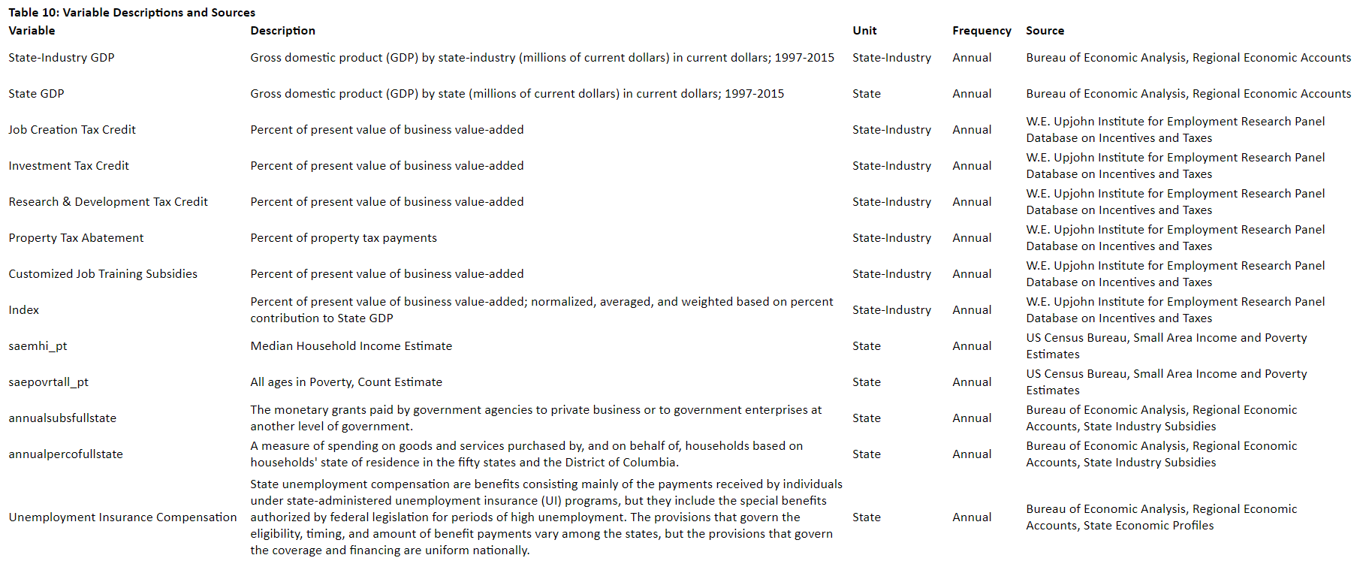
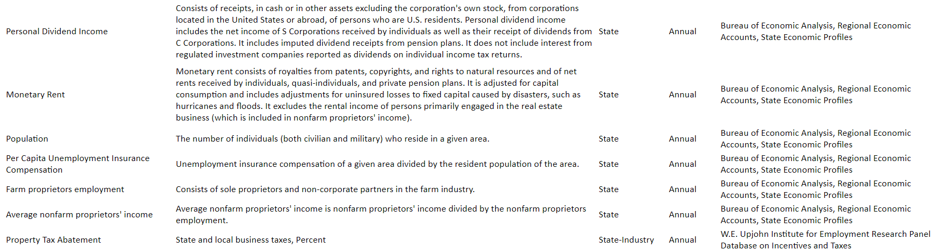

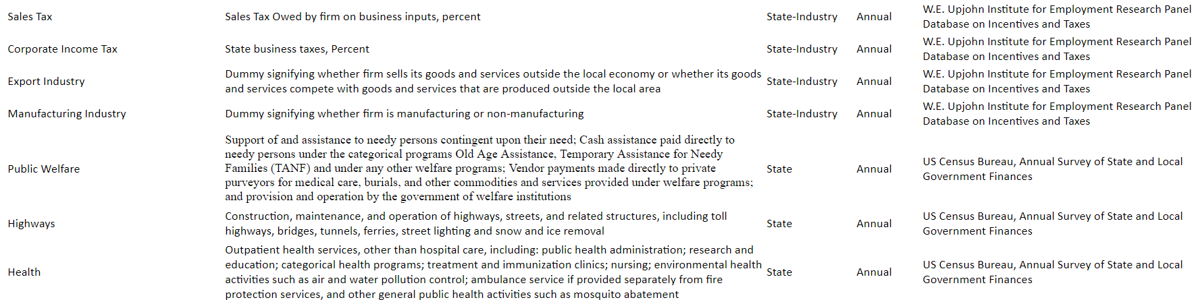
Appendix
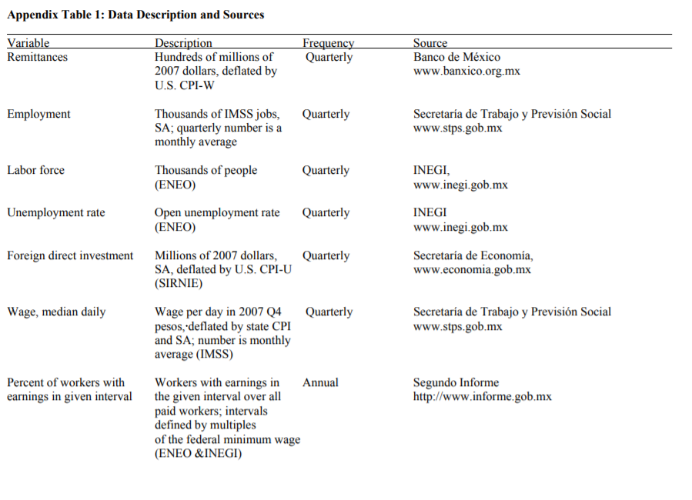

Industries defined according to NAICS codes at the three-digit level of specificity
Crosswalk can be accessed at https://www.naics.com/sic-naics-crosswalk-search-results/

